**MAKERERE**[](https://www.google.com/url?sa=i&rct=j&q=&esrc=s&source=images&cd=&cad=rja&uact=8&ved=0ahUKEwjUwMzp-ZfVAhWBXBoKHcHHAt4QjRwIBw&url=https://twitter.com/makerereu&psig=AFQjCNFCnD7pE6An3ZeMyoKNr1PrHNB8Nw&ust=1500643228129082) **UNIVERSITY**

**COLLEGE OF COMPUTING AND INFORMATION SCIENCE**

**SCHOOL OF COMPUTING AND INFORMATICS TECHNOLOGY**

**BACHELOR OF SOFTWARE ENGINEERING**

BSE 2301 Professional Software Engineering Mini Practical

**RECESS PROJECT II**

**GROUP MEMBERS**

|  |  |  |
| --- | --- | --- |
| **Name** | **Registration number** | **Signature** |
| Hyuha Gerald | 15/U/5174/EVE |  |
| Mwebaze Kenneth | 17/U/6872/EVE |  |
| Nyombi Nelson | 17/U/9420/EVE |  |
| Aheebwe Antony Sande | 17/U/19541/EVE |  |

# Table of contents

Table of contents ii

ABSTRACT vi

1.0 CONCEPT NOTE 1

1.1 PROJECT PROPOSAL 1

1.1.1 Problem 1

1.1.2 Proposed model 1

1.1.3 Main Objective 1

1.1.4 Specific Objectives 1

1.1. 5 Scope 1

1.1.6 Significance 2

2.0SOFTWARE REQUIREMENTS SPECIFICATION 3

2.1 Purpose 3

2.2 Document Conventions 3

2.3 Intended Audience and Reading Suggestions 3

2.4 Product Scope 3

2.5 References 3

2.6 Overall Description 4

2.6.1 Product Perspective 4

2.6.2 Product Function 4

2.6.3 User Classes and Characteristics 4

2.6 Operating Environment 5

2.7 Design and Implementation Constraints 5

2.8 User Documentation 6

2.9 Assumptions and Dependencies 6

2.11 External Interface Requirements 6

2.11.1 User Interfaces 6

2.12 Hardware Interfaces 7

2.13 Software Interfaces 7

2.14 Communications Interfaces 8

2.15 System Features 8

2.15.1 Data visualization 8

2.15.1.1 Description and Priority 8

2.15.1.2 Response Sequences 8

2.15.1.3 Functional Requirements 8

2.15 .2 Predict feature. 8

2.15.2.1 Description and Priority 8

2.15.2.2 Response Sequences 8

2.15.2.3 Functional Requirements 9

2.15.3 The download feature 9

2.15.3.1 Description and Priority 9

2.15.3.2 Stimulus or Response Sequences 9

2.15.3.3 Functional Requirements 9

2.16 OTHER NON FUNCTIONAL REQUIREMENTS 9

2.16.1 Performance Requirements 9

2.16.1 Safety Requirements 9

2.16.2 Security Requirements 9

2.16.3 Software Quality Attributes 10

2.17 Appendix A: Glossary 10

3.0 SOFTWARE DESIGN DOCUMENT FOR AIDS PREVALENCE DATA ANALYSIS SYSTEM 11

3.1 Introduction 11

3.2 Purpose 11

3.3 Scope 11

3.3.1 Objectives 11

3.3.2 Benefits 11

3.4 Overview 12

3.5 Reference Material 12

3.6DefinitionsandAcronyms 12

Software Design Document A document that completely describes all of the 12

IEEE 12

3.7 SYSTEM OVERVIEW 13

3.8 SYSTEM ARCHITECTURE 13

3.8.2 Decomposition Description 14

3.9 Design Rationale 16

3.10 DATA DESIGN 16

3.10.1Data Description 16

3.10.2 Logical Design 16

3.11COMPONENT DESIGN 17

3.12 HUMAN INTERFACE DESIGN 18

3.12.1 Overview of User Interface 18

3.12.2 Screen Objects and Actions 19

3.12.3 REQUIREMENTS MATRIX 20

4.0 The AIDS Prevalence Analysis Implementation Report 21

*Figure13 shows the uploaded file in spreadsheet format* 23

4.12 CONCLUSION 24

# ABSTRACT

The Aids Prevalence Data Analysis system project report is meant to present the finalized system that was proposed on **27TH JUNE 2019** with visualized screenshots that show how the system works, the problems the system was addressing, its scope, and the generalized architecture of the system.

The Aids Prevalence Analysis system was proposed to provide an accurate analysis platform for TASO data on a basis to improve the organization’s services to the public of infected individuals with AIDS. In order to provide good services, its data was analyzed and automatically generated visualized statistical analysis that can easily be read, compared and contrasted.

The accomplished system was able to meet the specifications and objectives of the organization and provided the necessary tools that were needed. An automated system replaced the manual system and mathematical experts hired to calculate and draw these visualized representatives of the data TASO collected in its field tours.

# 1.0 CONCEPT NOTE

## 1.1 PROJECT PROPOSAL

A system that analyzes the current statistics on AIDS prevalence related data to predict the future prevalence rates associated with AIDS.

### 1.1.1 Problem

There is insufficient planning for people living with AIDS in Uganda which has led to increased AIDS prevalence annually despite efforts made by organizations that support people living with HIV/AIDS. Denial of young people access to AIDS prevention methods and statistical datahave been distorted through the inaccurate extrapolation of data from small urban clinics to the entire population.

### 1.1.2 Proposed model

In order to tackle the above problem, we propose a predictive model for the AIDS Prevalence Analysis project so as to forecast the HIV/AIDS increase among the people in Uganda.

### 1.1.3 Main Objective

The purpose of this project is to design and develop a software analytics solution system basing on the current statistics on annual AIDS using different visualization techniques in order to minimize future AIDS increase through efficient planning and support for the people living with AIDS.

### 1.1.4 Specific Objectives

1. To analyze the infection levels among males and females for a given period of time in the country.
2. To find out how many children contract HIV/AIDS through mother to child transmission of HIV.
3. To find out the infection levels depending on age that’s to say 15 – 19, 20 -29, 30-39 and so on.
4. To find out where infections were highest among the widowed, unmarried or cohabiting couples.

### 5 Scope

The system shall be used by people or organizations who are interested in HIV related statistics of the people of Uganda.

### 1.1.6 Significance

* The system shall produce a visual representation of the statistics on AIDS prevalence among the different categories of people (female, male, youth, adults and children) in Uganda within specific age brackets inform of pie charts and graphs.
* The system shall predict the increase or decrease in AIDS in the years to come.
* The system shall determine the category of people who are most/least affected by AIDS in Uganda.
* The system shall help Organizations that support people living with AIDS in Uganda such as TASO to plan sufficiently for them.
* The system shall encourage the government to develop strategies that shall minimize AIDS prevalence in the future.
* The system shall encourage the emergence of more organizations and programs in the join to fight AIDS in Uganda.

# 2.0SOFTWARE REQUIREMENTS SPECIFICATION

## 2.1 Purpose

The purpose of this System Requirements Specification is to provide a full description of the requirements of the AIDS Prevalence Data Analysis Project. The system software requirements include both functional and non-functional requirements.

Functional requirements are functions that the system should do and non-functional requirements are requirements that can be used to judge the operation of the program such as performance etc.

## 2.2 Document Conventions

When writing this System Requirements Specification for the AIDS Prevalence Data Analysis Program different conventions were followed.

A Times New Roman Font was used. Main headings were given a font size of 14, and bold faced and the normal text was given a font size of 12.

## 2.3 Intended Audience and Reading Suggestions

This document is intended for TASO administrators and it will guide them in analyzing data about AIDS increase and guide in reducing the prevalence of the disease among the people.

## Product Scope

1. **TASO Project manager:** He is going to use this analysis report to find flaws in the current AIDS statistical data analysis and forward it to the top level administrators for decision making on how to improve and reduce on the AIDS.
2. **System Scope:** The results of this analysis is going to provide a report on how AIDS is getting common among people in the health sector.

## References

<https://www.tasouganda.org/>

<https://www.unaids.org/en/regionscountries/countries/uganda>

## 2.6 Overall Description

### 2.6.1 Product Perspective

1. The AIDS Prevalence data analysis programwill require use of a CSV file containing data from TASO AIDS records to fetch and display results such as the graphs, analyzed data, charts and others.
2. All the graphical representations are displayed on a user interface of this system installed on a local computer.

### 2.6.2 Product Function

1. To find out the infection levels depending on age that’s to say 15 – 19, 20 -29, and so on.
2. To find out where infections were highest among the widowed, unmarried or cohabiting couples.
3. To analyze the infection levels among males and females for a given period of time

### 2.6.3 User Classes and Characteristics

**User class 1- Project Manager**

1. Uploads the data files
2. Checks the analyzed data
3. Presents analyzed data to the top executives for decision making.

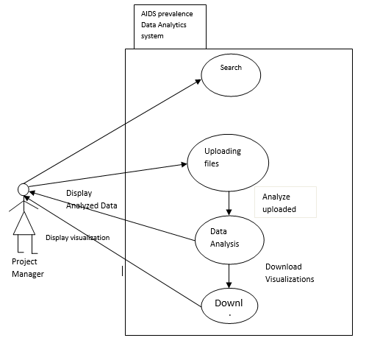

**Figure 1: use case diagram of the AIDS Prevalence Data Analysis Program.**

## Operating Environment

* The system is expected to operate on every hardware of a computer.
* It can also operate on all windows versions, Linux and Ubuntu.The system will run using any browser.

## Design and Implementation Constraints

* Programming standards: The organization will be responsible for maintaining the system because it is a long term project that has to be used with changing data throughout the years the hospital will be in operation.
* Unreliable internet since some of the resources have to be got from internet.
* Poor funding of the project.

## User Documentation

User documentations such as the project scope so far have been given in handy.

The users of this system shall refer to these documents for any further information about the AIDS Prevalence Analysis Program.

The program is under development stage and requires a complete implemented prototype to explain the user documentation.

## Assumptions and Dependencies

* Effort: The project will need fulltime commitment, hard work, research and team work.
* Schedule: The program will take 1 to 4 weeks including implementation.
* Resources: The project will be done by 3 to 4 members each with a computer connected to internet working for at least 5-6 hours every day.
* Budget: The project may cost a minimum of 500,000 Uganda Shillings for all the events and tasks.
* Software: The existing software will be used such as R studio.
* The system will depend on a CSV file which contains all the data that will be used to display the charts and graphs showing the data analysis.
* The existing software will be used such as R studio.

## 2.11 External Interface Requirements

### 2.11.1 User Interfaces

There will be designed interfaces to show the carried out analysis. Below is a sample of the main interface which is still under development in RStudio.

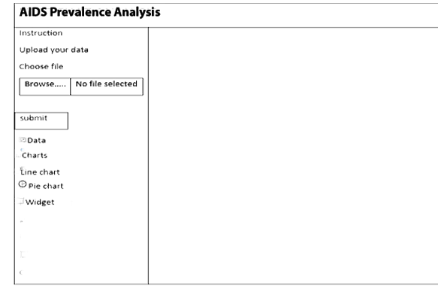

**Figure 2:User Interface**

## 2.12 Hardware Interfaces

This system will not require any special hardware designed in advance. The minimum requirement is a computer system with at least 2 GB of RAM, 500 GB of storage space.

## Software Interfaces

1. This System requires special packages like the shiny and dashboard packages which will all be downloaded to help in the designing of the user interfaces.
2. R-studio is used to edit and compile the source code. For Browser support, R-Studio contains a special browser to display the content.

## Communications Interfaces

The AIDS Prevalence Data Analysis System shall use the HTTP protocol for communication over the localhost since no internet connection shall be required.

## 2.15 System Features

## 2.15.1 Data visualization

### 2.15.1.1 Description and Priority

This is a collection of various visualization techniques that shall be used to analyze the AIDS data. Such visualization techniques include bar graphs, scatter plots, a word cloud to display most appearing n-grams and any others as will be required.

### 2.15.1.2 Response Sequences

The user uploads a comma separated value file to be analyzed and a confirmation message is displayed showing successful upload

## 2.15.1.3 Functional Requirements

REQ-1: Upload a csv file containing the data to be analyzed.

## .2 Predict feature.

### 2.15.2.1 Description and Priority

This feature will help give a future prediction of what will happen in the future such as an increase or decrease in the number of people commonly contracting AIDS depending on the variables that are defined. This is a high priority feature because it will help TASO executives to make better decisions in order to improve the strategies to reduce on AIDS increase.

### 2.15.2.2 Response Sequences

The user clicks on a line graph, line graph (uses data from the uploaded CSV file) is displayed on the dashboard then the user clicks the predict button and an improved line graph is displayed showing prediction of what will happen over a specified amount of time in the future.

## 2.15.2.3 Functional Requirements

REQ-2: Predict the increase or decrease in HIV Prevalence among females and males for a given period of time.

## 2.15.3 The download feature

### 2.15.3.1 Description and Priority

The download feature shall allow users of the AIDS Prevalence Data Analysis System to download for certain clients, pages depending on what they need.

This is a medium priority feature as users may not need to download the graphic visualizations every time. It depends on the needs of the users anyway.

### 2.15.3.2 Stimulus or Response Sequences

The user clicks the download and an image of format png is downloaded to their computer.

### 2.15.3.3 Functional Requirements

REQ-3: Download visualizations for the user.

## 2.16 OTHER NON FUNCTIONAL REQUIREMENTS

## 2.16.1 Performance Requirements

The AIDS Prevalence Analysis System shall not be hosted and has to be run from a local web server (Apache web server) on a local computer system.

It will also take an initial load time depending on the capabilities of the computer system and the size of the file.

## 2.16.1 Safety Requirements

To prevent failure of the software, the user should make sure that the file to be uploaded is a CSV file.

## 2.16.2 Security Requirements

The AIDS Prevalence Data Analysis System will only be disclosed to TASO executive who are responsible for decision making in the organizations that are fighting AIDS in Uganda.

## 2.16.3 Software Quality Attributes

**Reusability**

The system will be rebuilt, and enhanced to meet the new needs of the user. Therefore, newer versions of the systems will be released based on the demands of users.

**Usability**

The system has a good graphical interface which is easy to handle, use and navigate even for people with little knowledge about complex systems.

## 2.17 Appendix A: Glossary

**TASO**: The AIDS Support Organization

Browsers: A software application for retrieving, presenting, and traversing information resources on the wide world web.

**Developers:** These are people concerned with facets of the software development process, including research, design, programming, and testing of computer software.

**Shiny:**This is a package in R that has tools that are to be used in developing the user interface.

**CSV:** Comma Separated Values

**HTTP:** Hypertext transfer protocol, the set of rules for exchanging files such as texts, graphics, sound and other multimedia files on the web.

# 3.0 SOFTWARE DESIGN DOCUMENT FOR AIDS PREVALENCE DATA ANALYSIS SYSTEM

## 3.1 Introduction

The AIDS prevalence data analysis project is meant to provide analysis of AIDS prevalence among various categories of people visit TASO. The results of this analysis will be used by TASO administrators to improve their services and reduce the commonness of AIDS among the people.

## 3.2 Purpose

The purpose of the Software Design Document is to provide a full description of the design of the AIDS Prevalence data analysis system to allow software development to proceed with an understanding of what is to be built and how it is expected to be built.

It also provides information necessary for the description of the details for the software to be built.

## 3.3 Scope

1. **TASO Project manager:** He is going to use this analysis report to find flaws in the current AIDS statistical data analysis and forward it to the top level administrators for decision making on how to improve and reduce on the AIDS.
2. **System Scope:** The results of this analysis is going to provide a report on how AIDS is getting common among people in the health sector.

### 3.3.1 Objectives

* 1. Predict the increase or decrease in HIV Prevalence among females and males for a given period of time.
  2. To find out the infection levels depending on age that’s to say 15 – 19, 20 -29, 30-39 and so on.
  3. To find out where infections were highest among the widowed, unmarried or cohabiting couples.

### 3.3.2 Benefits

1. The system shall produce a visual representation of the statistics on AIDS prevalence among the different categories of people (female, male, youth, adults and children) in Uganda within specific age brackets inform of pie charts and graphs.
2. The system shall predict the increase or decrease in AIDS in the years to come.
3. The system shall determine the category of people who are most/least affected by AIDS in Uganda.
4. The system shall help TASO that supports people living with AIDS in Uganda such as TASO to plan sufficiently for them.

## 3.4 Overview

1. **The introduction:** This provides a detailed description of the purpose, scope and objectives of the AIDS Prevalence Data Analysis System.
2. **The System Overview:** This section gives a general description of the functionality and context of the AIDS Prevalence Data Analysis System.
3. **The System Architecture:** This section provides a detailed description of all components and modules that make up the complete system.

It also describes various design implementations used during the development of the system.

1. Other sections include the data design section which describes how data is manipulated to produce the desired results and the component design which provides a summary of algorithms of each of the functions of the system.

## 3.5 **Reference Material**

[1] <https://www.tasouganda.org> TASO Uganda, 2019.

[2]<https://www.unaids.org/en/regionscountries/countries/uganda>UN AIDS, 2019

[3] <http://www.cs.mu.oz.au> Introduction to UML: Structural Modelling and Use Cases, 2000

[4] <http://www.SoftwareEngineering-9.com> Software Engineering by Ian Sommerville

[5] <http://www.wiley.com/college/dennis> System_Analysis_Design_UML5th Dennis Wixom Roth

## 3.6Definitions**andAcronyms**

Term Definition

Software Design Document A document that completely describes all of the functions of a proposed system and the constraints under which it must operate

IEEE Institute of Electrical And Electronics Engineers

*CSV Comma Separated Values*

## 3.7 SYSTEM OVERVIEW

Generally, the system will allow users to upload a CSV file. The uploaded file shall be used to show how AIDS is prevailing among the various categories of people using word cloud or any other visualization technique as may be needed.

The uploaded data will also be used to provide a prediction of how many people might contract the disease over a specified amount of time.

The results of this analysis will be used by the TASO executives (administrators) to find out what needs to be worked upon immediately in order to improve the services it offers to the people.

**Below is a generalised overview of how the user interacts with the AIDS Prevalence Data Analysis system.**

**Figure 3: A generalized overview of how the user interacts with the AIDS Prevalence Data Analysis system**

Results returned to the user

User

3.8 SYSTEM ARCHITECTURE3.8.1 Architectural Design

The proposed system is a data analysis system.

The architecture used for the system is a Client/Server Architecture where a client can use Internet browsers to access the analyzed data.

The user first acquires access by logging in into the system.

The system has the interface which contains:

* Login section: this provides access to the user into the system.
* Upload section: this is where the file with data is uploaded from
* Display section: this is where the charts showing analyzed data are displayed.

The user (project manager) upload the file which contains data to be analyzed.

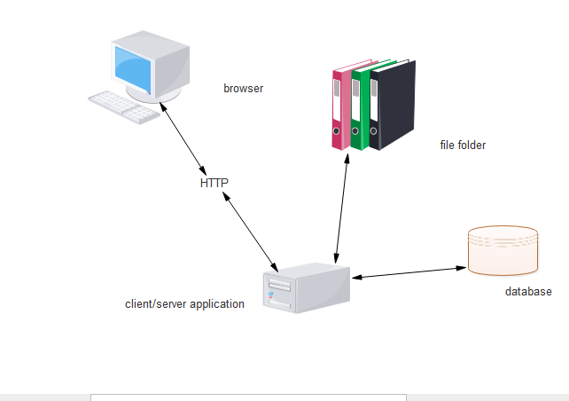

**Figure 4:Architectural Design**

### 3.8.2 Decomposition Description

**Context diagram showing the flow of data**

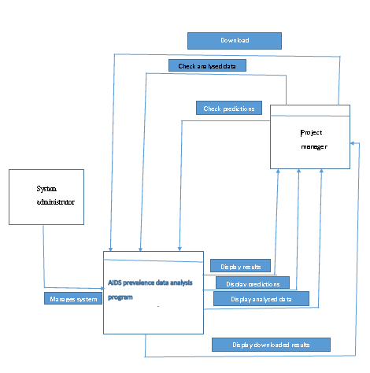

**Figure 5: Context diagram of dataflow**

**Level 0 diagram for dataflow**

Manager: the system manager accesses permission into the system by logging in. He then uploads the file that contains data to be analyzed.

The analyzed data is then displayed in form of charts.

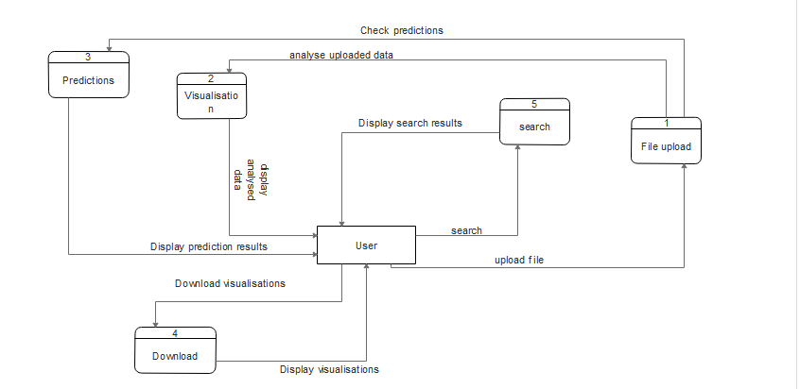

**Figure 6: Level 0 diagram for dataflow**

## 3.9 Design Rationale

We selected client/server architecture because there is a request made by the browser (client) to upload the file. The file is uploaded as the way of servicing the request from the client.

## 3.10 DATA DESIGN

This section is about the persistent data management. Persistent data management deals with how the persistent data (file, database, etc) are stored and managed and it outlives a single execution of the system.

Information related to user data and other basic information is persistent data and hence stored in a CSV file.

### 3.10.1Data Description

The data contained in a csv file which is made up of rows and columns is uploaded in the system by the user, then converted into a list data structure then diagnosed into simpler formats like bar graphs, pie-charts and word cloud using instructions written in R in the server.

## 3.10.2 Logical Design

In order to upload and display information persistently we map objects into tables and the attributes into fields to the specific table based on the objects found on the system.

We shall upload the data to be analysed from a csv file that we currently carrying out data cleaning so that we customise it our needs so that’s we give the variables that we are going to use.

***Table 1: Data to be analyzed***

|  |  |  |  |  |  |
| --- | --- | --- | --- | --- | --- |
| HospitalName | ID | SampleNumber | NumberOfInfections | Percentage | Year |

**Table 2: Data to be analysed more fields**

|  |  |  |  |
| --- | --- | --- | --- |
| Category | Region | Sex | Age |

## 3.11COMPONENT DESIGN

This section provides a summary of some of the algorithms and pseudocode that were used to develop each component of the AIDS Prevalence Data Analysis system.

**Table 3: Summary of algorithms and pseudocode**

|  |  |
| --- | --- |
| **COMPONENT** | **PSEDUDOCODE** |
| FILE UPLOAD | Click browse and select file  IF (file is CSV)  THEN file is uploaded successfully  ELSE  File failed to upload  ENDIF |
| VISUALIZATION | IF (CSV is uploaded)  THEN Navigate the dashboard  IF (chart is selected)  THEN display chart data  ELSE  Select chart again  ELSE  Upload CSV file again  ENDIF |
| PREDICTIONS | IF(File is uploaded)  THEN Click predictions button  THEN SELECT Charts  ELSE  Upload the file again  ENDIF |
| DOWNLOAD | Click download button  IF (File Exists)  THEN Display success message  ELSE  Download failed  ENDIF |

## 3.12 HUMAN INTERFACE DESIGN

### 3.12.1 Overview of User Interface

The user will upload a CSV file by using the upload button, analyse the uploaded data by clicking on the widgets on the interface and the system will display the visualisations including downloading the results if needed by the user using the download button.

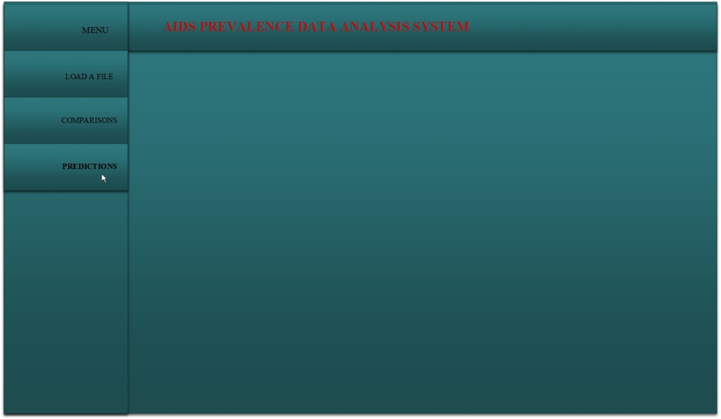

**Figure 7: Diagram showing the main interface that’s acts as the main page**

### 3.12.2 Screen Objects and Actions

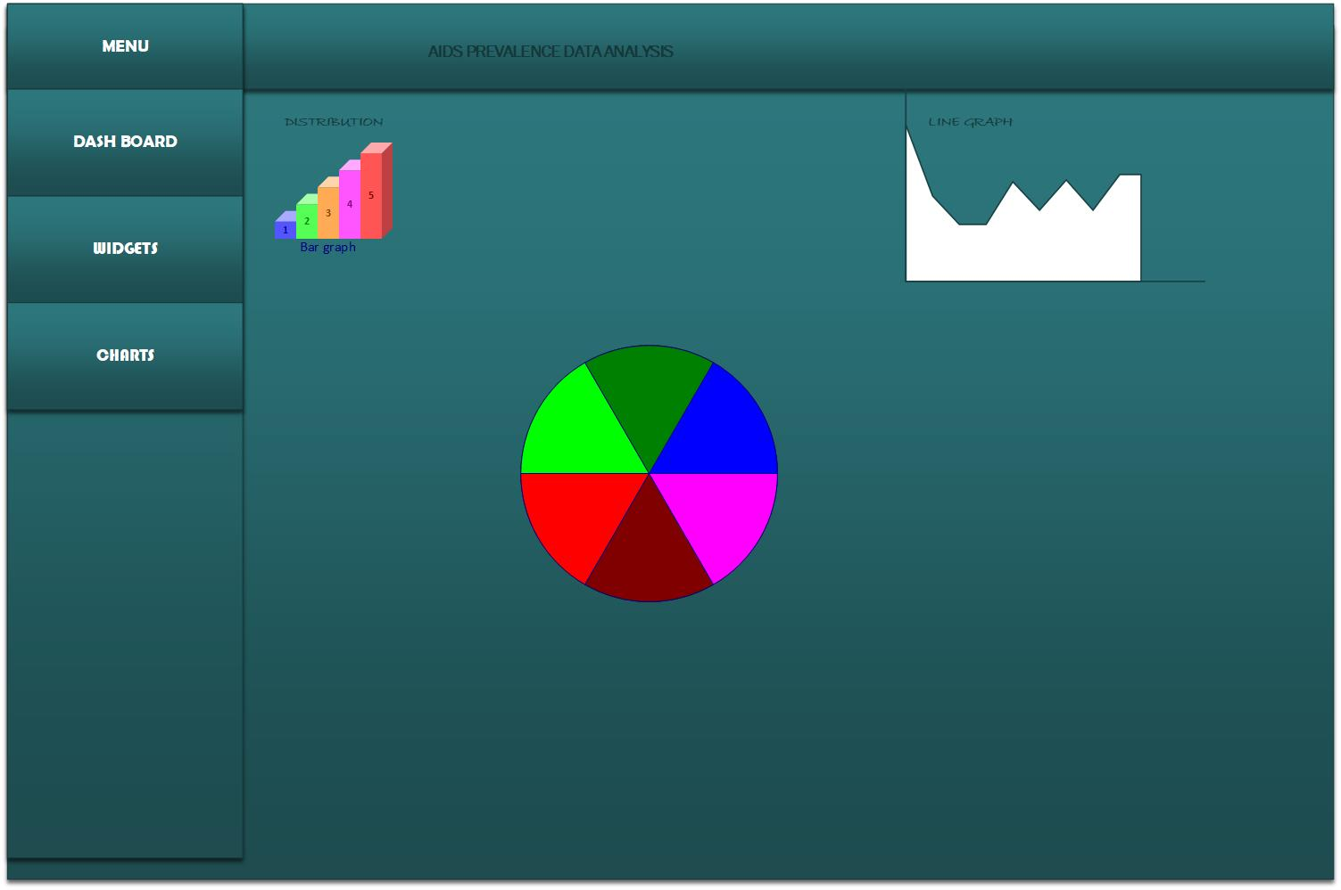

### 3.12.3 REQUIREMENTS MATRIX

UC stands for use case.

**Table 4: Requirements matrix**

|  |  |  |  |  |
| --- | --- | --- | --- | --- |
| **Components:**  **Requirements from SRS**  **(use cases):** | **Download**  **Component** | **Upload File** | **Analyse Uploaded Data** | **Display Analysed Data** |
| UC |  |  |  |  |

# 4.0 The AIDS Prevalence Analysis Implementation Report

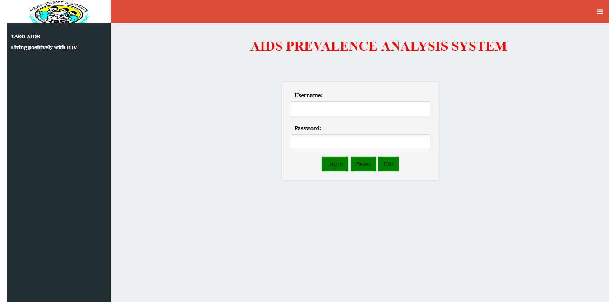

**Figure 8: The User log-in interface for the AIDs Prevalence Analysis system**

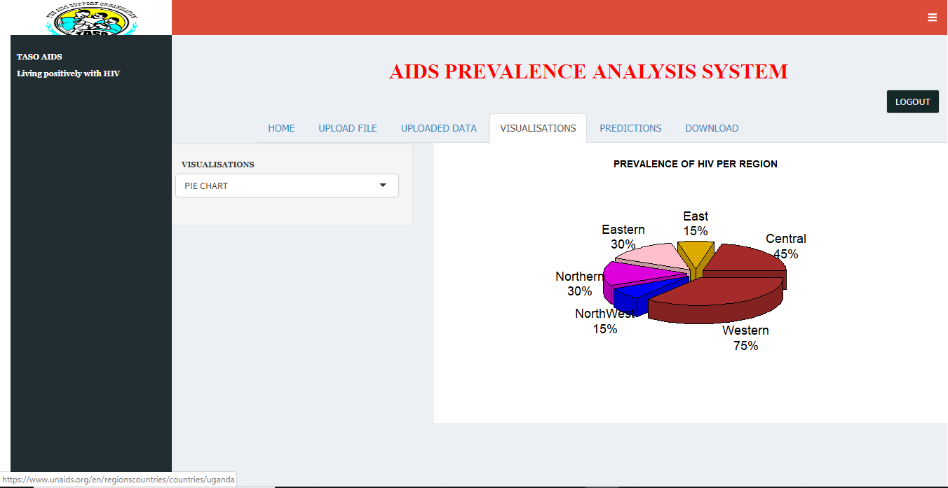

**Figure10 Shows the Pie-chart of infections among different regional hospitals**

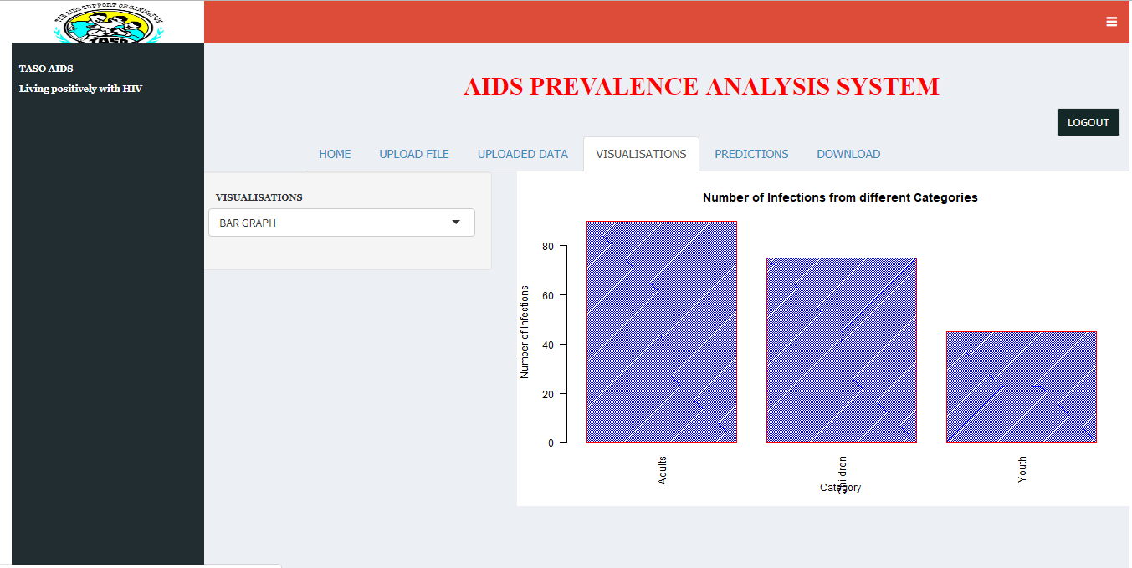

**Figure 11 shows a Bar graph representing activities of different categories**

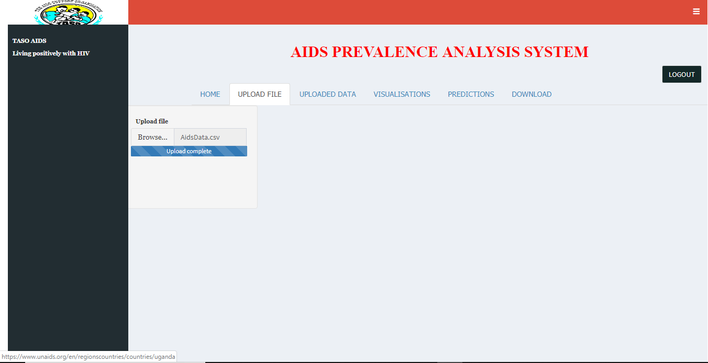

**Figure12 shows how uploads are done and analyzed**

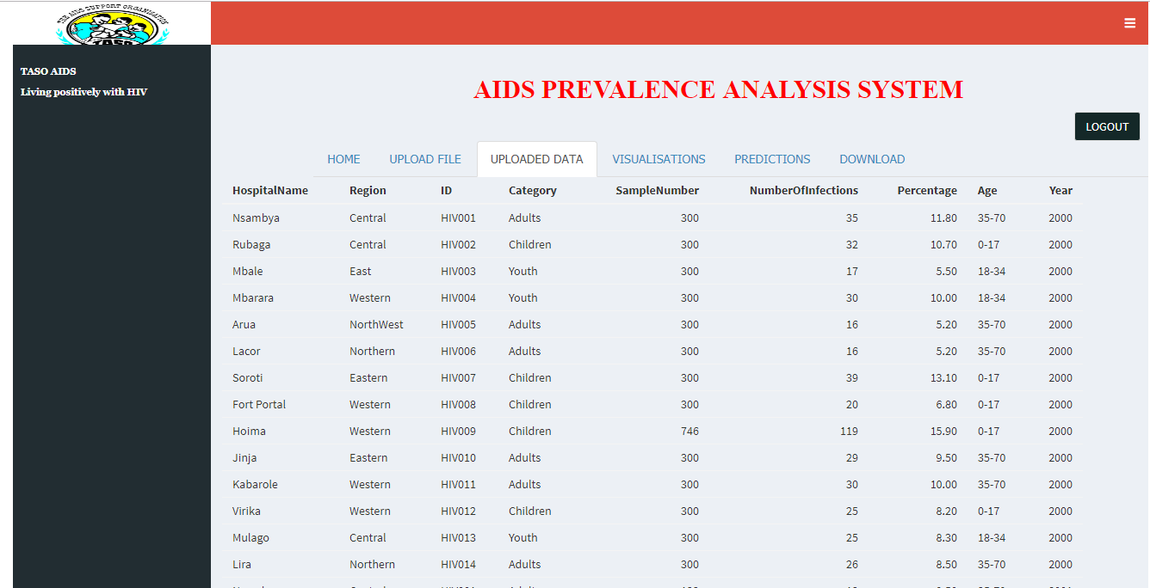

### *Figure13 shows the uploaded file in spreadsheet format*

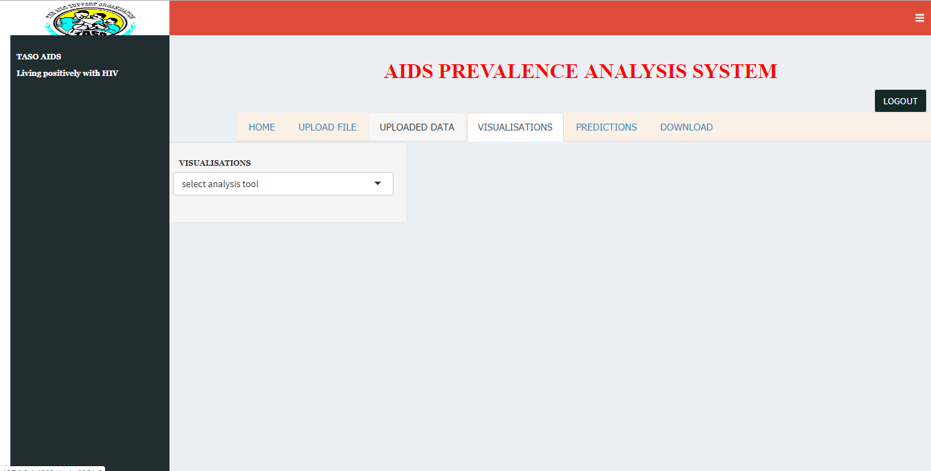

**Figure 14 shows all available Data analysis tool a user can choose apply**

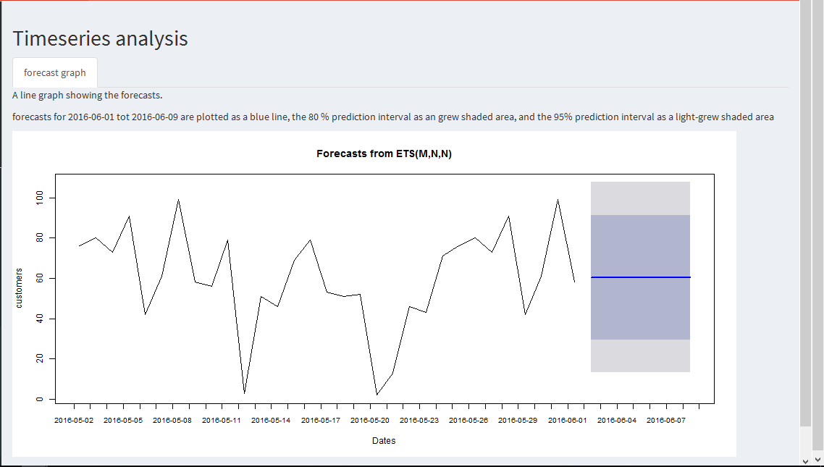

**Figure 14 shows a Line graph representing the user predictions performed**

## 4.12 CONCLUSION

The major aim of designing **The Aids Prevalence Data Analysis System** was to provide an automated and improved solution to TASO that would analyze all field collected data. The results of the analysis would be handed over to TASO by the operation staff to the overall executives who in return provide better services compared to the earlier service.